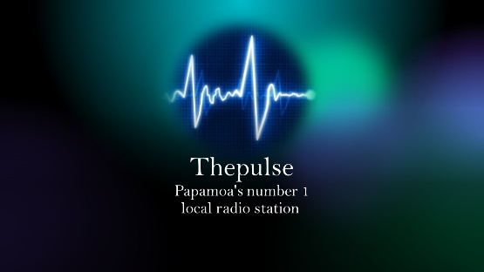

A new and exciting radio station is on the scene and it is Thepulse, Papamoa’s local radio station! As this is a new venture we can all support each other to grow and so I have decided that for the rest of the year I am offering FREE ADVERTISING on the station. However also for you information I have added the prices for future advertising in 2022.

Service $
15 second Announcer/Ad lib lines Free 20.00
30 second Announcer/Ad lib lines Free 40.00
Full advert (price may vary depending on length) Free 60.00

Advert created from scratch (and receive a copy) 150.00

Station Special for 2022
15 second Announcer/Ad lib lines
30 second Announcer/Ad lib lines
Two full adverts 70.00

Expect to hear your business mentioned 5 to 6 times per week with this package.

Contracts are on a monthly basis and can be cancelled at any time. Should you wish to set up a 4 month or 6-month contract in advance this can also be arranged.

This is your chance to get the word out there to the local community about your business. Get in touch to let them know about your business and what you offer.

Tune in online or on 106.9 FM
Darren McColl

